

Daventry Shuttle

A Weedon Station Project concept

**Next review due:** Jan 21st 2022

**Published by:** Sustainable Transport Northamptonshire

**Written by:** Harry Burr, on behalf of Sustainable Transport Northamptonshire

**Helpful link(s):** <https://weedonstation.site>, <https://premetro.co.uk>, <http://www.parrypeoplemovers.com/>

Contents:

1. Route and fares
   1. South Northants Link and other project routes
   2. No WCML running
   3. No destruction of any kind
   4. The route we would use.
   5. A one-track railway
   6. Unlimited commuter season ticket
   7. Smartcard system, flexible system
   8. Single and return journeys.
   9. How much will it cost (+ student discounts)
2. Rolling stock and frequency
   1. Pre-Metro Operations Class 139
   2. Amount of units
   3. Maintenance depot
   4. Time at station
   5. Every 15-20 mins
   6. Miss a service, take another one. Flexible
3. Environment
   1. No diesel
   2. Battery trains
4. Operator: Private or public?
   1. London Northwestern
   2. A future main line connection

# 1. Route and fares

## South Northants Link and other project routes

A vital thing we need to get right on this project is to not use the unbelievably valuable old alignment. By old alignment, we mean the route between Weedon and Leamington Spa. For any future reopening of this corridor, we need to remember to keep the alignment clear of any project like this, only making sure in the rail scheme of things, it is used for future heavy rail/light rail long routes, not a shuttle service.

## No WCML running

In this area of the West Coast Main Line, many developments may happen after HS2 Phase 1 is complete, taking advantage of the reduced capacity. These include East West Rail going up the West Coast Main Line, a high-speed service at Northampton, and of course, Daventry Parkway. At this point, we do not want to add to this new congestion (although less than before HS2) by putting an essentially slow metro on it. Instead, we will implement new tracks beside the WCML, dedicated to this new shuttle. It would not save a lot of money moving onto the WCML for some of the journey anyway.

As well as this, if a line such as the South Northants Link is approved, heavy or tram-train type rail, we will need this capacity on the West Coast to allow their trains to run efficiently with significant speed partly on the WCML.

## No destruction of any kind

A hard thing to do in 2021, but one of our main goals for this concept is *to not* destroy anything on the way, or damage buildings/the environment etc. We will take measures to make sure this promise is taken seriously, including choosing new alignments in benefit of the buildings and the greenery on route. For us, we think this will be relatively straightforward, by instead of going South East out of Daventry, we instead go North East, also at the same time *avoiding* the precious old alignment I was speaking of earlier.

## The route we would use

As I was saying, we will go North as opposed to South out of Daventry for this shuttle service. I am going to simply explain the route here in this infographic:

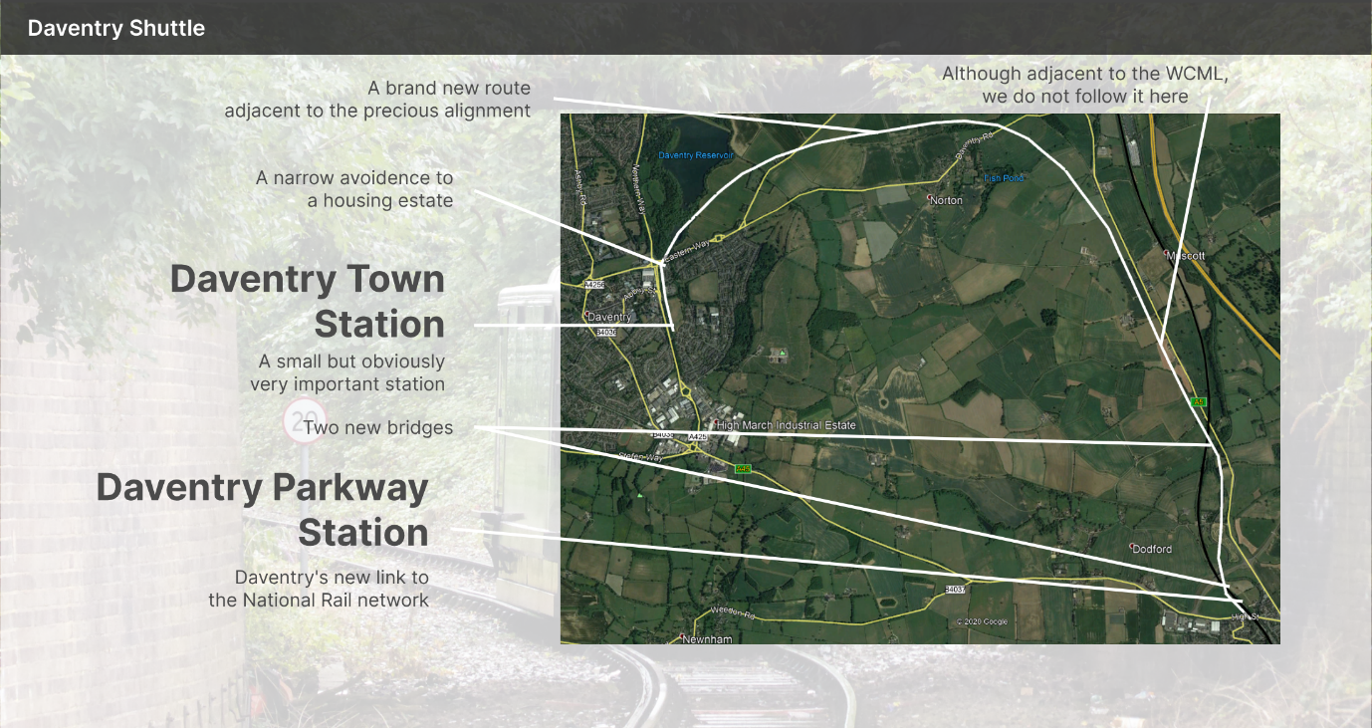

## A one-track railway

Compare this proposed system to the Stourbridge Shuttle for a second. It is short, it’s between a large town and another railway station, and it might even use the same rolling stock. It is basically a duplicate of the shuttle in Stourbridge, but in Daventry instead. And a shuttle service does not need two tracks. It can work perfectly fine with one. Stourbridge run a 10min frequent service between Town and Junction (with no stops) on a one-track railway. We can do that too.

## Unlimited commuter season ticket

When I first came up with this idea, I thought *this is going to be expensive for a frequent passenger*. Then I came up with this idea. A yearly payment to have an Oyster-type contactless card (more on this in the next section) which gives you unlimited travel between the two destinations. This makes it a lot easier for the end consumer, who does not have to factor in, firstly, the journey between London Euston and Daventry Parkway, and then another journey secondly, between Daventry Parkway and Daventry Town. It will essentially be a separate system to the rest of the National Rail network.

## Smartcard system, flexible system

Miss your train? No worries just take a later service, which will probably be here in 15 minutes anyway. Forgot your ticket? Do not worry about it, use your debit card.

These are some of the examples a technologically advanced system like Oyster can fix. Instead of having to buy a ticket on somewhere like Trainline, you can do one of the following:

1. Use your debit card to pay for a single journey by just using it as a contactless card at the two terminuses.
2. Get one of our Smartcards, to either load:
   1. Top-up on, to pay for single journeys until the top-up expires.
   2. A season ticket on, which allows unlimited travel between the stations.
3. Buy a paper ticket traditionally, with either a single or a return.

## Single and return journeys.

As I have just said, as an alternative to a season ticket, you can also purchase a single journey from one terminus to another either on your smartcard, via your debit card, or with a paper ticket. These single journeys will cost little to nothing, to allow commuters to efficiently get from home to work without having to pay a massive amount more on the home stretch.

## How much will it cost (+ student discounts)

I have covered how this will all work, but not how much the fares will cost. Refer to the below table for some help with that:

|  |  |  |
| --- | --- | --- |
| **Type of ticket** | **No student discount** | **W/student discount** |
| Monthly season ticket | £30.00 | £20.00 |
| Yearly season ticket | £325.00 | £250.00 |
| Single | £1.20 | £0.80 |
| Return | £2.40 | £1.60 |

# 2. Route and fares

## Pre-metro operations Class 139

Going back to relation with the Stourbridge Shuttle, Class 139s. I have chucked some specifications up on the right for you to have a look at, but essentially, it is a really small EMU. It is one car of course and has a capacity of around 60 people sitting and standing.

It seems to be a theme for using this stock to create shuttles to train stations. In 2010, a trial service on the Mid-Hants railway was attempted, however, the project was cancelled. Of course, Stourbridge Shuttle connects the town and Junction station together, another example of using 139s to shuttle to train stations.

As well as this West Midlands Railway have experience with 139s, as they oversee the Stourbridge Shuttle service, which is operated by Pre-Metro Operations.

## Amount of units

Currently, the Stourbridge shuttle operates 2 units, and swaps them every day or so (139001 and 139002). On this line, 2, 3, or 4 would make the most sense. As it is expected to get a higher passenger count and will be a longer journey, 3 or 4 makes the most sense.

## Maintenance depot

At Stourbridge Junction, the 139 that is not in use is stored in a shed at the end of the line. This would be something we would implement at Daventry Parkway (Weedon end), except the depot would be larger to fit the three trains that would not be in use at the time, or the same size if only two were used to operate the branch.

## Time at station

We expect the train to spend around 2½ minutes at every end. If someone misses this service, they can just catch the next one. If we find out this is not enough time, we can increase it.

## Every 15-20 minutes

We expect the journey to take around 10 minutes on the alignment we have selected. With a stop at every station for 2½ mins and space for flexibility, this works out at approximately a 20-minute frequent service at every end.

## Miss a service, take another one. Flexible.

As mentioned two paragraphs above, if you miss the frequent service, just take a different one. No need to buy another ticket or call us to rebook, just hop on the next service to either end using your contactless card or debit card/season ticket. No complications necessary.

# 3. Environment

## No diesel

Another one of our big promises is to use no diesel on the link whatsoever. Whether that’s diesel stock, diesel used in our maintenance depot, or diesel used in any way at our stations. For this proposal, diesel is off limits.

## Battery trains

Of course, if we are not going to use diesel, we need to use an alternative source. Now, the manufacturer of the Class 139s, Parry People Movers, are yet to announce a battery train. But it is becoming a trend, eventually it is likely PPM will release a battery version of their Class 139. If they do not, then a third-party can convert it anyway. Trains currently running on the Marston Vale Line could be a good alternative to Class 139s if the above is not possible. They are Class 230s, manufactured by a new start-up called VivaRail. The trains running on the MVL are not battery, but other versions of the Class 230 are, such as the Diesel Battery hybrids which will be operated by TfW. See image below:

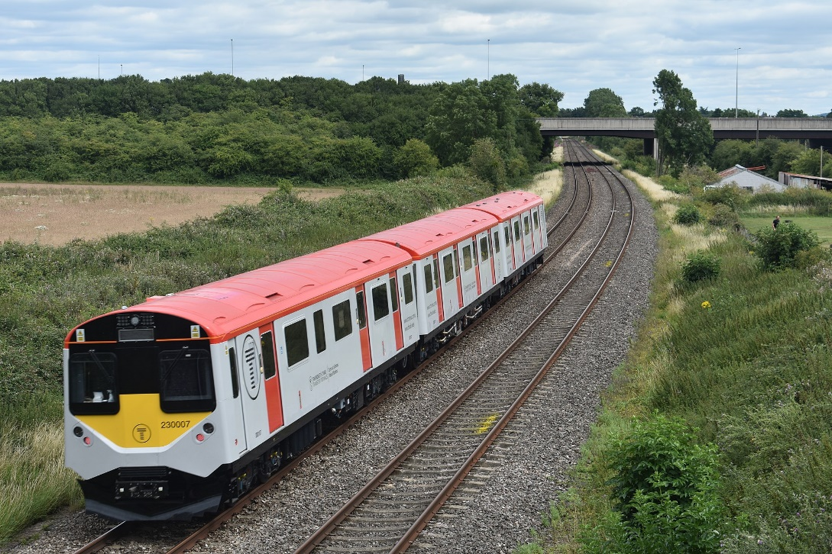

# 4. Operator: Private or public?

## London Northwestern

* London Northwestern Railway, owned by West Midlands Trains, have many relations to this project.
* They will operate Daventry Parkway station, and operate most, and if not, all, services calling there.
* They have experience, as they run the Stourbridge Shuttle in West Midlands, as mentioned.
* A huge majority of services calling at Northampton are operated by them, and most in Milton Keynes and Rugby are too.
* London Northwestern Railway are subsidised by the Government, so can take on financial risk, unlike a private company.

## A future main line connection

As I have mentioned in this document, a new future main line connection could be implemented running to Leamington Spa on the old Weedon – Marton Junction line alignment, just adjacent to this proposed route. In the case this is approved, passenger use on the shuttle will drop rapidly, as the new main line will be faster.

However, less frequent by far, and commuters may still continue to use the Daventry Shuttle if a main line connection is opened due to this reason, frequency. Also, a big factor, cost. Daventry Shuttle for passengers will cost a *lot* less than a main line train would, and the tickets are more flexible and a better system overall, with improved season ticketing too.

The problem we need to address here is if the shuttle is owned and operated by a different company. In this case, they might suffer dramatic passenger losses due to the competing publicly owned railway right beside it. However, if the branch was owned by a public operator and operated by London Northwestern, this would be no problem at all, because the new main line just adjacent will be operated by London Northwestern Railway too.